Date: 2010.12.23
New format:
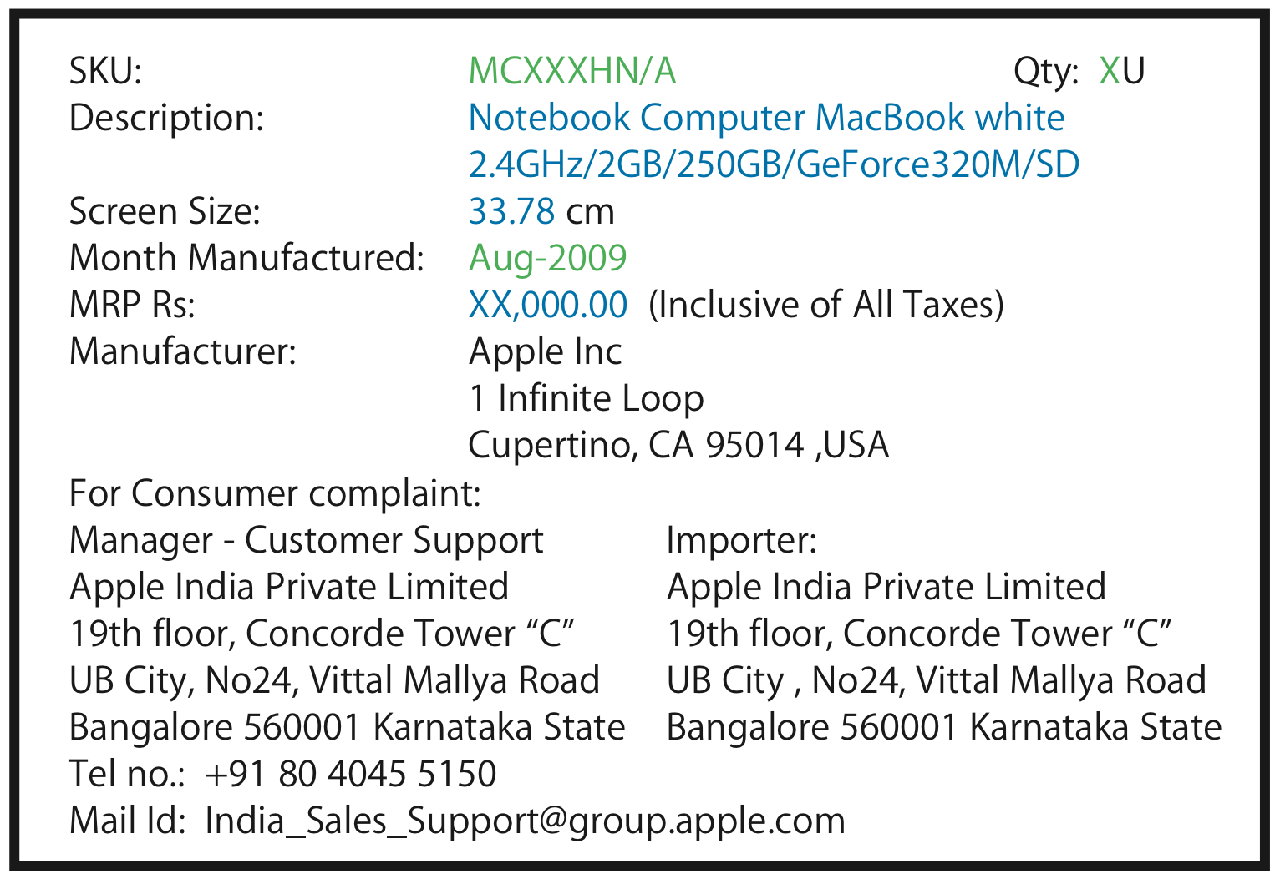
Changing Text: Green is sourced by the factory. Blue is supplied by Apple via BOM text.

OLD Format:
